



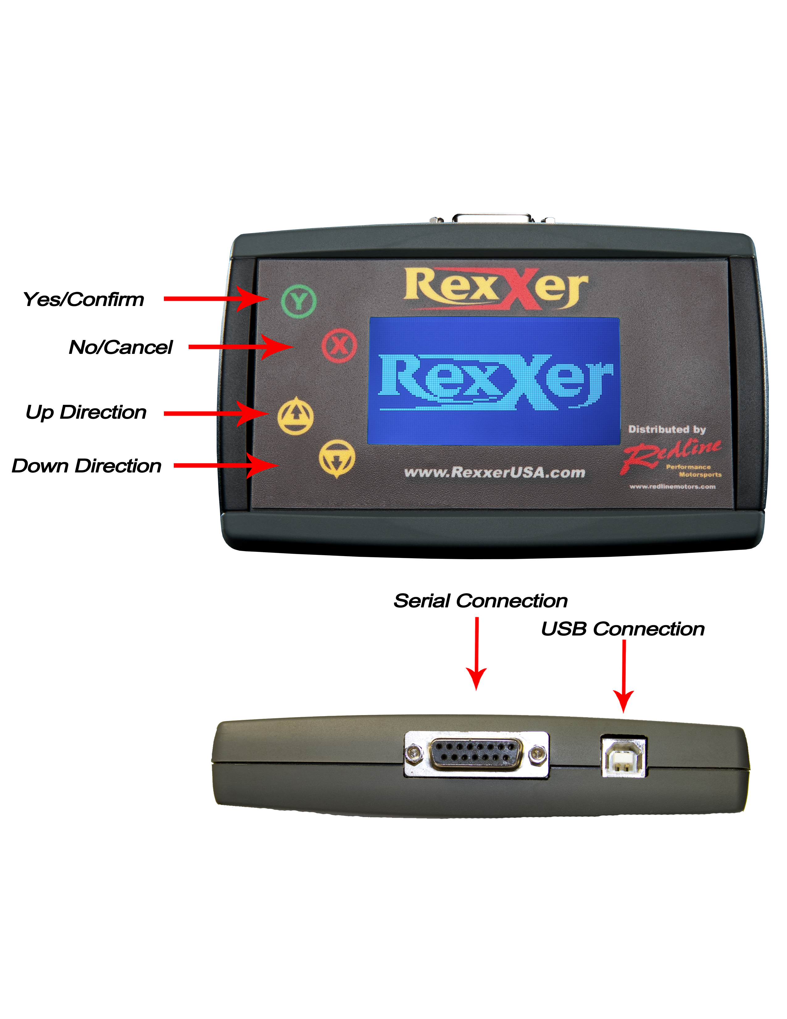


Battery must be fully charged before operation!
Never have the Rexxer User connected to the Computer and Motorcycle simultaneously!
If O2 sensors were disabled, disconnect from the electrical connector(s). (They do not have to be removed from the exhaust.)

Steps:
1- Connect the Rexxer User to the bike with provided cable.

2-
The Rexxer User will automatically power up.

3-
The Rexxer User Reads and saves the stock map.

4- The Rexxer User will write custom map from

5-
Disconnect Rexxer Unit.
If warning is shown, select
Follow the screen prompts
www.rexxer.com
For Software, Manuals, Additional Backups and troubleshooting visit.
Features of Rexxer User as a Service Tool including TPS Resets, Adaptive Parameters, Trimmer, and CEL read/clear. Can be found in the User Guide
ECU Form.
V2.4
Rexxer ECU Tuning
Quick reference Guide
Rexxer ECU Tuning
7331 George Washington Memorial Highway
Yorktown VA, 23692
david@rexxer.com
www.rexxer.com

Rexxer User
Quick Reference Guide
V2.4
Rexxer ECU Tuning
Quick reference Guide

